Honors Pre-Calc/Trig Unit 7 Assessment
Name ___________________________

Level 2/Basic

1. Find the vertex of y=6(x+5)²+4 1. _____________________

2. What number must be added to x²-20x to complete the square? 2. _____________________

3. Find the x-intercepts of y=5x²-5x-100 3. _____________________

4. Find the y-intercept of y=x²-7x+6. 4. _____________________

5. Solve using the quadratic formula: x²-8x+13=0 5. _____________________

6. What are the roots of f(x)=5(x²+16)(x+3)? 6. _____________________

7. Divide using synthetic division: (x²-4x+3) ÷ (x-5). 7. _____________________

8. Create a function of the form y=f(x) that has roots of 1, 2i and -2i. 8. _____________________

9. What is the degree of f(x)=9x⁷-6x⁸-9x-6? 9._____________________

10. What is the leading coefficient of f(x)=2x⁴-4x⁸-5x⁵-11? 10._____________________
11. Find the vertical asymptote of 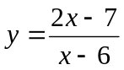 11._____________________
12. Find the horizontal asymptote of 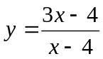 12._____________________
13. For what x-value(s) is 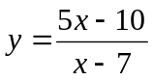 not continuous? 13._____________________

14. Find 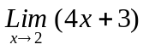. 14.__________________

15. Use a calculator to find the real zero of f(x)=2x³-7x²+4x+5 to 3 decimal places. 15.__________________

Name ___________________________

Level 3/Proficient

1. Write the equation of a parabola with vertex (5, 2) that goes through (4, -2). 1. _____________________

2. Find the slant asymptote of 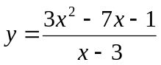 2. _____________________

3. Describe the end behavior of y= 3x⁴+6x³+3x²+1 3. _______________________________________

4. Describe the end behavior of y= -2x³+6x²+8x+4 4. _______________________________________

5. (x+5) is a factor of x³+5x²+16x+80. Find two other factors. 5. _____________________

6. x=2 is a root of x³-10x²+33x-34. Find all complex roots. 6. _____________________

7. Write the equation of a rational function with vertical asymptotes at
x=1 and x=-3, and horizontal asymptote at y=2. 7. _____________________

8. Find 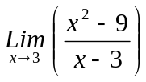. 8.__________________
9. Find 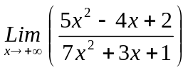. 9.__________________
10. Find 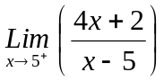. 10.__________________

Name ___________________________

11. Sketch the graphs. Label all asymptotes and important points (such a vertices or intercepts):
a) y= -2x²+20x-48 b) f(x)= -(x-2)⁵+3 c) 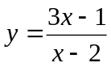 d) 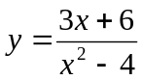


12. Expand using partial fractions: 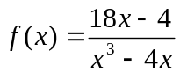 12. _______________________________________

13. Find the inverse of y=(x+2)³-3 13. __________________________

14. Solve the inequality for x: x²-3x > 28 14. __________________________

15. Solve the inequality for x: 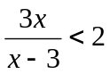 15. __________________________

Level 4/Advanced

1. Using a limit, find the slope of the tangent line to y=3x²+4 at x=4.

2. Let f(x)=ax⁷+bx³+cx-4, where a, b, and c are constants. If f(-5)=7, then find f(5).

Name ___________________________

3. The roots of f(x) are 3, 4, and 2. What are the roots of f(x²+1)?

4. A parabola equation y=ax²+bx+c is reflected about the x-axis. The parabola and its reflection
are translated horizontally 5 units in opposite directions to become the graphs of y= f(x) and y= g(x), respectively. Which of the following describes the graph of y=(f + g)(x)? (Explain)
(A) a parabola tangent to the x-axis (B) a parabola not tangent to the x-axis
(C) a horizontal line (D) a non-horizontal line (E) the graph of a cubic function

5. The graph of f(x) consists of four line segments: One line segment from (-7, -4) to (-2,6), a second line segment from (-2, 6) to (0, 0) a third line segment from (0, 0) to (1,6), and a fourth line segment from (1, 6) to (5, -6). How many solutions does the equation f(f(x))=6 have? (Justify your answer. You do not need to find the solutions, just how many there are.)

